**(1) Write a blog on the difference between document and window objects.**

**Difference between document and window objects**

**Document Object**

The document object represents a web page that is loaded in the browser. We can access the element in the HTML page by accessing the document object. With the help of document objects, we can add dynamic content to our web page. The document object can be accessed with a window.document or just document.

**Syntax:**

**Document.property_name;**

**Window Object**

The window object is the topmost object of the DOM hierarchy. It represents a browser window or frames that display the contents of the webpage. Whenever a window appears on the screen to display the contents of the document, the window object is created. The window object can be accessed with a window.property_name.

**Syntax:**

**Window.property_name;**

**Window Vs Document**

**Window object:**

It is the topmost object and outermost element of the object hierarchy, as shown in the Hierarchy of Window and Document objects using BOM and DOM.

The window object represents a window/tab containing a DOM document.

**Document object:**

--> Each HTML document that gets loaded into a window becomes a document object. The document contains the contents of the page. Using document objects, JavaScript can modify, add, and delete the HTML elements, attributes, and CSS styles on the page.

Document object is a property of window object that points to the DOM document loaded in that window.

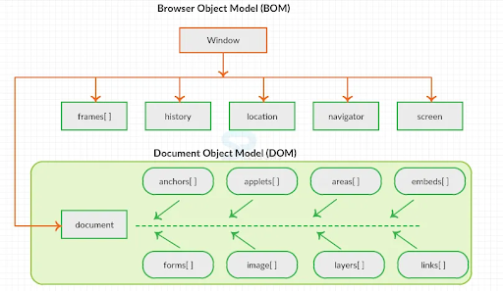

The other major difference is that window and document objects have properties and methods. A few method names are identical in both objects but with different behavior. In the below figure (example) window.open() opens a new tab or window and document.open() creates a blank document within the window.

Refer to the Example figure.

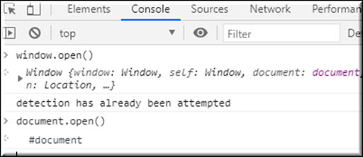

**Difference between document and window objects**

|  |  |
| --- | --- |
| **Document** | **Window** |
| It represents any HTML document or web page that is loaded in the browser. | It represents a browser window or frames that display the contents of the webpage. |
| It is loaded inside the window. | It is the very first object that is loaded in the browser. |
| It is the object of window property. | It is the object of the browser. |
| All the tags, elements with attributes in HTML are part of the document. | Global objects, functions, and variables of JavaScript are members of the window object. |
| We can access the document from a window using the window. Document. | We can access the window from the window only. i.e. window.window. |
| The document is part of BOM (browser object model) and dom (Document object model). | The window is part of BOM, not DOM. |
| Properties of document objects such as title, body, cookies, etc can also be accessed by a window like this window. document.title. | Properties of the window object cannot be accessed by the document object. |
| Syntax:  document.property_name; | Syntax:  window.property_name; |
| Example: document.title : will return the title of the document. | Example: window.innerHeight : will return the height of the content area of the browser. |